Mrs. Kim Klappauf 7th Grade History B204
WelcomeOl! This year we will be focusing on three units: Civics, which includes study of the federal and state Constitutions, Westward Expansion and Manifest Destiny, and Civil War and Reconstruction. Many of our lessons will be based on the History Alive! curriculum, but we will also be using the Discovering Our Past textbook as a resource-primarily the online version. Throughout the year the students will have the opportunity to work in cooperative groups. One of my primary goals is that the students will be able to connect our study of American history to their modern-day lives, so we will also be utilizing the Junior Scholastic news magazine and other periodicals.
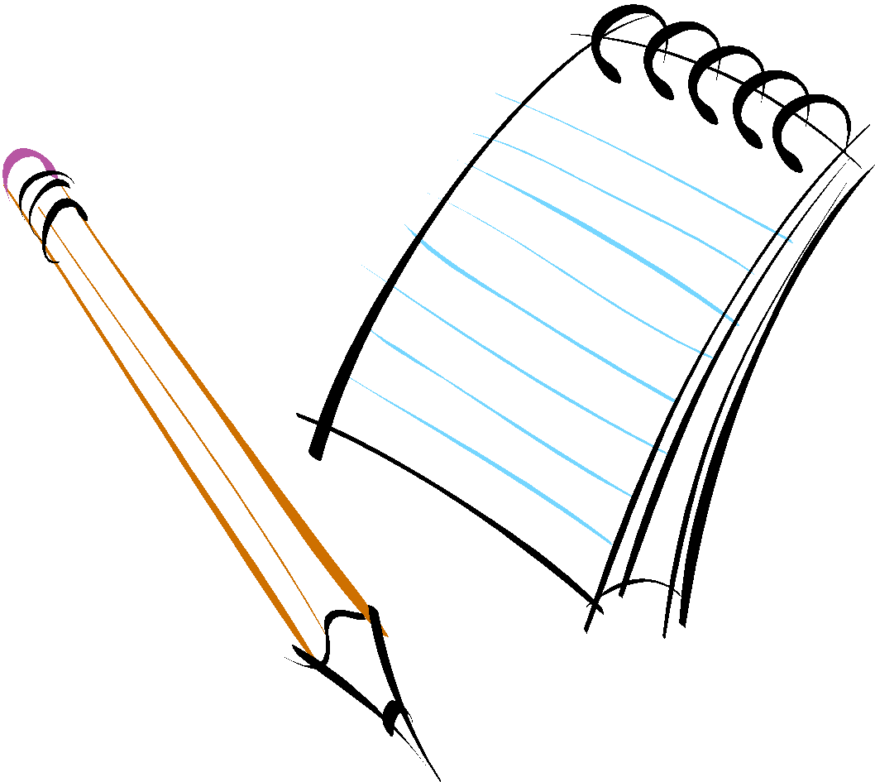
I require all my students to come prepared to class with: A folder dedicated to History A spiral notebook Writing utensils A Positive Attitude ☺

“If you want to understand today, you have to search yesterday.” -Pearl Buck-
I have only three rules, and they are very simple to follow.
BE RESPECTFUL BE RESPONSIBLE BE SAFE

I assign homework to reinforce concepts that have been introduced in class. It will be posted on The Olympians website each day. Students are encouraged to speak with me if they are having difficulty completing assignments or projects. Stressed students are not successful students!
Your children may be in the adolescent stage of life, but they still need your support. Please speak with your child each day about what happened at school. Discuss world events with them. Monitor Skyward for assignments and grades. Read with them. Assure them that we are working together for their success. Do not hesitate to contact me if you have any questions or concerns. The number at school is 342-4870, or you can email me at klappaufk@mokena159.org.

Conferences are Thursday, November 7 from 12:00PM-8:00PM. Watch for information about scheduling yours!
I look forward to working with you!

